Multiple-choice section

|  |  |  |  |  |  |  |  |  |  |  |  |  |  |  |  |
| --- | --- | --- | --- | --- | --- | --- | --- | --- | --- | --- | --- | --- | --- | --- | --- |
| Question | 1 | 2 | 3 | 4 | 5 | 6 | 7 | 8 | 9 | 10 | 11 | 12 | 13 | 14 | 15 |
| Answer | B | B | A | D | C | B | D | B | A | B | D | B | C | A | A |

Question 1 [5.1]

B

Sum means add, therefore x + 7 is correct.

Question 2 [5.1]

B

Liam has s + 5, so if Angela has double, she has twice that amount: 2(s + 5).

Question 3 [5.1]

A

Product means to multiply so xy is correct.

Question 4 [5.1]

D

x, y, z

Pronumerals are letters used in an equation or expression.

Question 5 [5.1]

C

Difference means subtraction, so n – 6 is correct.

Question 6 [5.4]

B

 = 1

Question 7 [5.6]

D

The pronumeral component must be identical, so 7a is a like term.

Question 8 [5.6]

B

Collect like terms only.

3p + 6p = 9p

6 is an unlike term.

Question 9 [5.3]

A

Multiply x by 2 means 2x. Then subtract 7.

Question 10 [5.4]

B

j = 3 × 5 + 2 = 17

Question 11 [5.4]

D

D is incorrect because 12 – 3 = 9 not 8.

Question 12 [5.5]

B

Every one shape uses 4 matches, so m = 4s.

Question 13 [5.7]

C

x is negative and y is positive, so (-2, 4) is in the second quadrant.

Question 14 [5.8]

A

Each y value is 1 more than double the x value.

Question 15 [5.9]

A

Becky is shorter than John.

Multiple-choice total marks: 15

Short answer section

Question 16 3 marks [5.2, 5.7]

(a) The expression 2a + b + 3 contains three terms.

(b) In the expression 2x + y + 7, the ‘7’ is called the constant.

(c) The point (0, 3) is on the y-axis.

Question 17 2 marks [5.2]

The number written in front of a pronumeral is the coefficient.

e.g. 3x + 1 the coefficient of x is 3, for the expression 1 – 2x coefficient of x is -2.

Question 18 2 marks [5.3]

A flowchart is a step-by-step instruction for performing a set task.  
e.g. 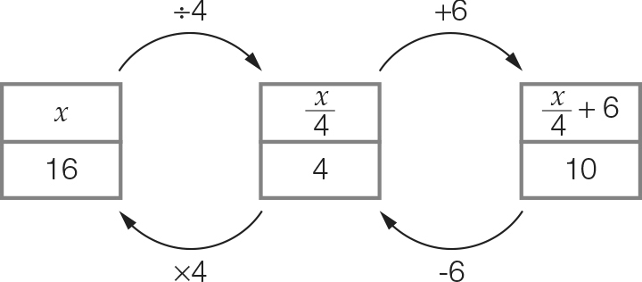

Question 19 1 mark [5.1]

Add all side lengths: x + y + z

Question 20 3 marks [5.1, 5.6]

(a) d – 3 (b) d + (d – 3) = 2d – 3

Question 21 2 marks [5.1]

1 rose = 12 petals and 1 daisy = 7 petals

So 12r + 7d petals

Question 22 1 mark [5.1]

There are half the number of each animal in the first diagram, so m ×  = 

Question 23 2 marks [5.2]

6m + 3 = 15

Question 24 6 marks [5.3]

(a)

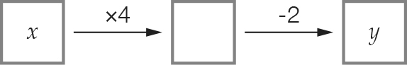

(b) y = 4x – 2

(c)

|  |  |  |  |  |
| --- | --- | --- | --- | --- |
| x | 1 | 2 | 3 | 10 |
| y | 2 | 6 | 10 | 38 |

Question 25 3 marks [5.3]

(a) y =  (b) y = 3(x + 2) (c) y = x2 + 3

Question 26 2 marks [5.3]

y = 4x – 3

Question 27 2 marks [5.3]

From each y-value subtract 5.

|  |  |  |  |  |
| --- | --- | --- | --- | --- |
| x | 5 | 7 | 11 | 15 |
| y | 10 | 12 | 16 | 20 |

Question 28 5 marks [5.3]

(a)

|  |  |  |  |
| --- | --- | --- | --- |
| Number of cards, n | 5 | 7 | 12 |
| Cost to produce the cards, C | 60 | 66 | 81 |

(b) C = 45 + 3n

Question 29 2 marks [5.4]

(a) 2(3 + 1) = 2 × 4 = 8 True (b) 3 × 7 – 5 = 21 – 5 = 16 False

Question 30 2 marks [5.4]

|  |  |  |  |  |
| --- | --- | --- | --- | --- |
| m | 4 | 8 | 12 | 15 |
| n | 10 | 14 | 18 | 21 |

Question 31 2 marks [5.4]

w =  = 6

Question 32 4 marks [5.5]

(a)

|  |  |  |  |  |
| --- | --- | --- | --- | --- |
| Number of shapes, S | S | 1 | 2 | 3 |
| Number of matches, M | M | 7 | 13 | 19 |

(b) M = 6S + 1

Question 33 6 marks [5.6]

(a) 8k (b) 6t (c) 8xy

(d) 7a + 3 (e) 9p + 3 (f) 7m + 7n + 4

Question 34 4 marks [5.6]

(a) (y + x) + (y + x) = 2(y + x) = 2y + 2x

(b) (y + x) + (y + x) + (y + x) + (y + x) + (y + x)  
= 5(y + x) = 5y + 5x

Question 35 6 marks [5.7]

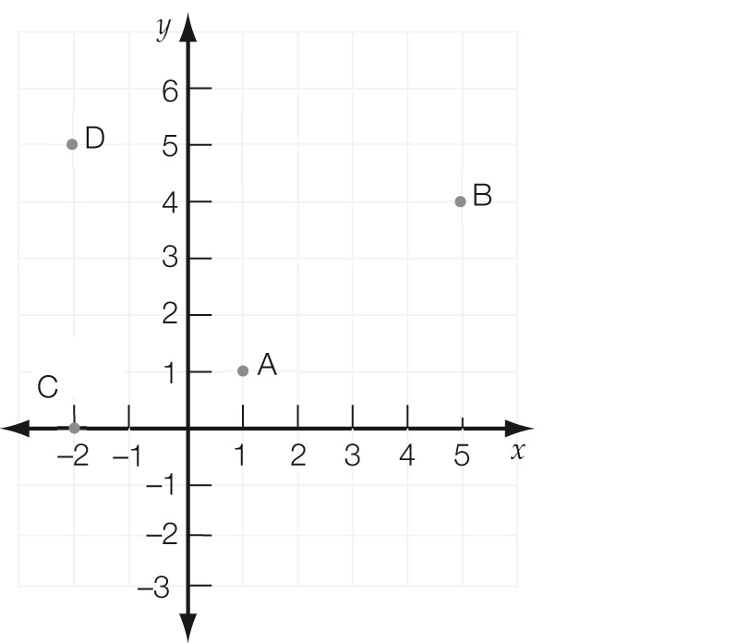

(a) A (1, 1), B (5, 4), C (-2, 0), D (-2, 5)

(b) A: 1st quadrant.  
D: 2nd quadrant.

(c) C

(d) (2, 5)

Question 36 7 marks [5.8]

(a)

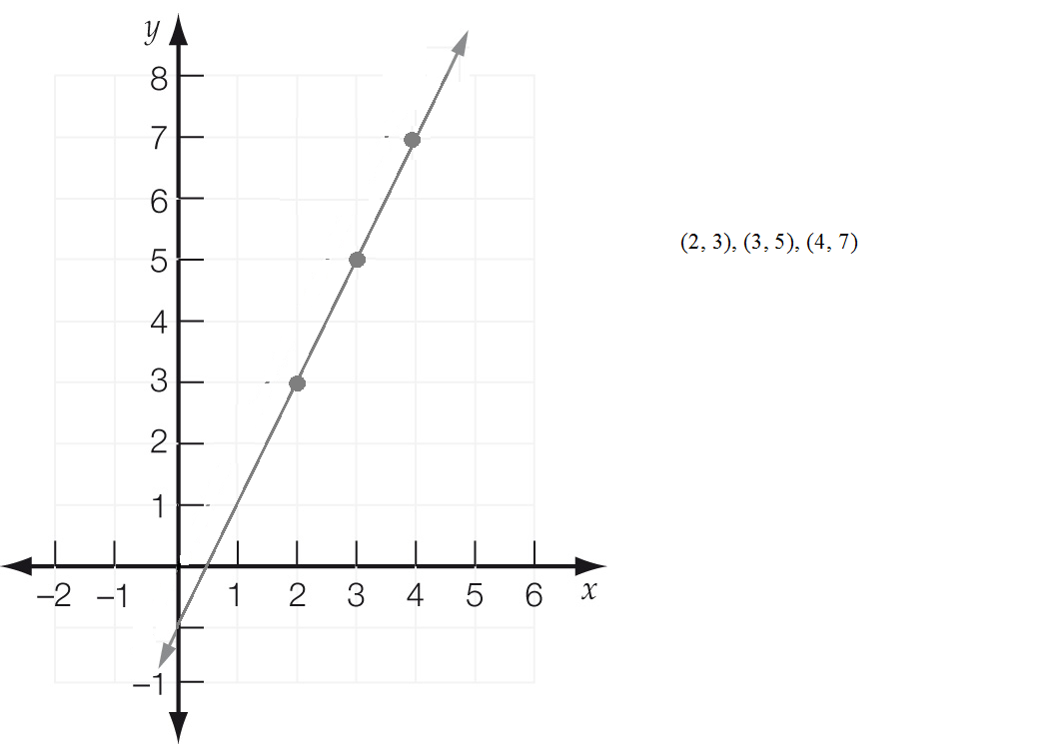

(b)

|  |  |  |  |
| --- | --- | --- | --- |
| x | 2 | 3 | 4 |
| y | 3 | 5 | 7 |

(c) y = 2x – 1

(d) sample answer: (5, 9)

Question 37 3 marks [5.9]

A mouse, B elephant, C giraffe

Question 38 3 marks [5.9]

(a) False

(b) False

(c) True

Question 39 8 marks [5.9]

(a) (i) A is 10 am because he rests after 1 hour.

(ii) B is 10:30 am

(iii) C is 2 pm because he has lunch for an hour.

(b) 3 km

(c) From 2 pm until 5 pm is 3 hours.

(d) 6 km + 6 km = 12 km

Short answer total: 81

Extended answer section

Question 40 6 marks [5.3]

(a) $110 + $85 × 3 = $365 (b) C = 110 + 85d

(c) 450 = 110 + 85 × d  
d = , d = 4 hours

Question 41 10 marks [5.8]

(a)

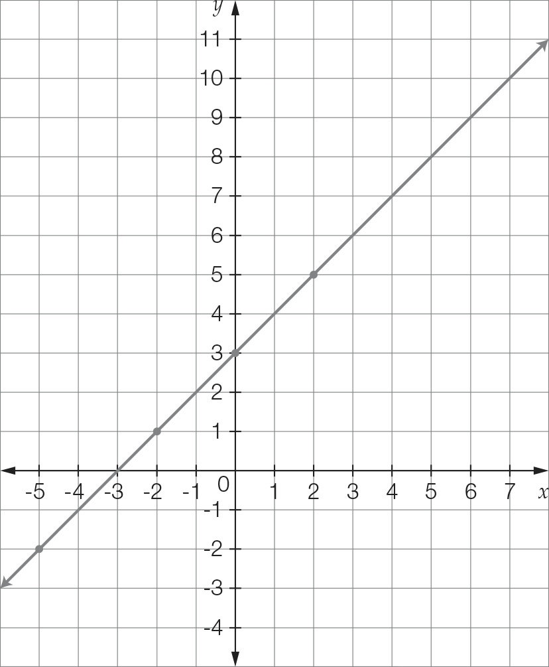

(b)

|  |  |  |  |  |
| --- | --- | --- | --- | --- |
| x | -5 | -2 | 0 | 2 |
| y | -2 | 1 | 3 | 5 |

(c) y = x + 3

(d) if x = 5, y = 5 + 3 = 8

(e) No. The point (-1, 1) is below the line y = x + 3.

Question 42 4 marks [5.9]

(a) No. The cheapest car has the lowest fuel consumption but the most expensive car does not have the highest consumption.

(b) The 4 cylinder car is the cheapest car to drive because it has the lowest fuel consumption.

Extended answer total: 20

TOTAL test marks: 116